E-Meter System Design and Alternatives

The following section examines the E-meter system design at a functional level. Figure 1 breaks down each of the major functional levels of the E-metering system. The three areas of design that will be broken down are electronic hardware, mechanical hardware, and software.

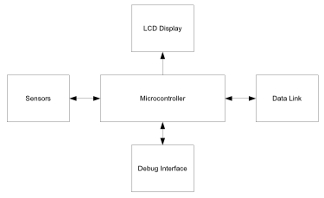

Figure : Functional block diagram

Electronic Hardware

At the center of the PICA E-meter is a TI MSP430 processor, specifically tailored for three-phase metering applications. TI constructed the F471xx family of processors to be power efficient, running on 1.8V and drawing 350uA running at 1MHz. The system includes seven 16-bit Sigma-Delta analogue-to-digital converters, six of which perform metering while the seventh can be used for tamper protection or temperature readings. The MSP430 drives a 160-segment LCD display showing the current usage as measured in kilowatt-hours. Two LEDs provide visual indication of system status.

ANSI codes C12.19 and C12.21 require that any electronic metering device display the current usage at the local metering unit. Thus, the LCD display on the E-meter refreshes after every measurement to show the updated instantaneous usage, cumulative usage, and system status. In order to be compliant with FCC Title 47 part 15, regarding low-power radio transmissions from electronic equipment, only parts built in compliance with this statute will be used in the design.

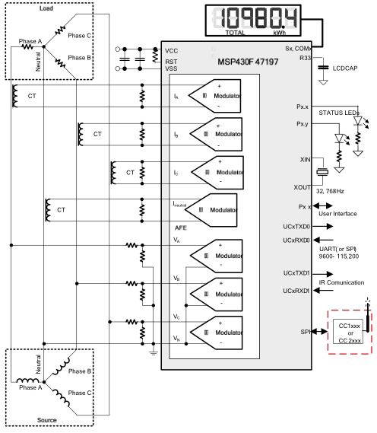

Figure : MSP430 System

Attaching current transformers to each phase of the line voltage allows the E-meter to monitor the current draw from each phase. The hot and neutral lines of each phase pass through the meter to allow for measurement on each phase. The wiring inside the meter that passes through the current transformer must be capable of handling the current draw of the installation; thus, #4/0 wiring is used for any line voltage. Similarly, a resistor and capacitor network provides input to measure the voltage on each phase of the 3-phase system.

As the e-meter collects data, it transmits the data back to the PICA base station or the utility company via a customizable interface which supports Zigbee radio, Ethernet, and serial rs232 communication protocols. The MSP430 provides support for all of these communications directly with one exception; Ethernet requires an extra microprocessor and hardware to handle the TCP/IP protocol.

In an eventual production unit Zigbee radio can provide the most bandwidth and longer range transmission of data back to the utility company. Additionally, the RS232 interface may disconnect to prevent tampering with internal settings.

Mechanical Hardware

Line Attachment Hardware

The E-meter system provides six screw-terminals on the base of the unit for connecting the pass-through current loops. Likewise, four screw-terminals connect the three phases and neutral lines to the meter input networks. Each of the current sense inputs physically interrupts the supply lines, thus the mounting hardware includes redundant fasteners protecting against accidentally disconnecting the service line voltage.

Enclosure

In order to protect the E-meter components from the outdoor environment the system must be enclosed in a weatherproof case. The E-meter enclosure is composed entirely of ABS, heat resistant plastics. Plastics ensure that a loose wire cannot energize the case while still providing the durability of many metals. The case design allows for easy mounting on a variety of surfaces using standard fasteners and allows for access to the user interface controls.

UI Hardware

The E-meter provides several push buttons for changing the displayed contents of the built-in LCD screen. A closable lid protects the push buttons from the weather, as the power meter must be mounted on the exterior of the building. A protective glass window covers the LCD display. The design team chose glass because it can resist yellowing and remain transparent for a longer time than plastics when exposed to extreme outdoor temperatures.

Software

User Interface

The user interface for the E-meter consists of a push button and a 160 segment LCD display module. For debugging purposes, the initial prototype includes an RS232 port capable of interfacing with PC software to load configurations and monitor internal dataflow.

Monitoring Algorithms

The background monitoring algorithm inside of the MSP430 microcontroller take measurements from the seven Sigma-Delta ADCs containing current and voltage data. Then for each monitored phase the E-meter removes any residual DC offset present in the measurement, accumulates samples for instantaneous power measurements, and accumulates I\_RMS and V\_RMS computations. This algorithm will monitor for 1 second, storing each reading in onboard memory; then after 1 second of data is collected, generate an interrupt to the main process, calculate frequency and power factor, and transmit all data to the foreground process. The foreground process then updates the LCD display, calculates values for RMS current and voltage, and calculates active and reactive power, and finishes by transmitting all data out over the Ethernet link before waiting for a new interrupt from the background process.

|  |  |
| --- | --- |
| foreground_process.pdf  Figure : Foreground process | background_process.pdf  Figure : Background process |

Alternatives

Very few alternatives exist for automated meter reading (AMR) and e-metering applications. Texas Instruments MSP430 SoC is the first in this class of embedded systems widely available and commercially produced. Several other vendors supply various components, such as sensors and processors that combined can produce similar results. That said, TI also provides a reference design for using their MSP430F47197 in an automated E-meter application, making this a very attractive solution for the design team.

Analogue Devices provide the closest competing chip for measuring energy consumption. The ADE7763 measures everything the TI MSP430F47197 does, but requires 1 chip per phase and an external microprocessor for control. This provides an obvious disadvantage, requiring more parts to accomplish the same task.